LeetCode_3_Longest Substring Without Repeating Characters

# LeetCode_3_Longest Substring Without Repeating Characters

## 题目介绍

**Longest Substring Without Repeating Characters**

[**https://leetcode.com/problems/longest-substring-without-repeating-characters/description/**](https://leetcode.com/problems/longest-substring-without-repeating-characters/description/)

**难度:Medium**

Given a string, find the length of the longest substring without repeating characters.

Example 1:

Input: "abcabcbb"

Output: 3

Explanation: The answer is "abc", which the length is 3.

Example 2:

Input: "bbbbb"

Output: 1

Explanation: The answer is "b", with the length of 1.

Example 3:

Input: "pwwkew"

Output: 3

Explanation: The answer is "wke", with the length of 3.

**Note that the answer must be a substring, "pwke" is a subsequence and not a substring.**



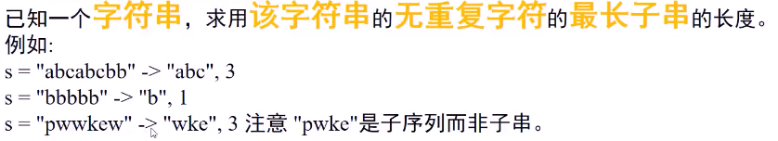

## 思路分析

* 思路分析：结合哈希表与滑动窗口共同实现。

*首先利用两个指针，left和right，一个result记录最大长度；

*初始时left和right都指向开头，result=0，然后right向右移动，利用布尔哈希表统计字符在当年窗口是否存在，

\***布尔哈希表**默认为false，若字符第一次出现，则设置true，若某字符第二次出现，先计算当前窗口的长度，

* 与result比较，若大于result则更新result，然后将left指针向右滑动，滑到该字符第一次出现之后为止，

*并将移除窗口的字符设置false； 就是始终保持哈希表的字符对应为true，其他都为false；

*不断与result判断，寻找最大长度；

* 当right指针到达字符串末尾即结束；最后result保存的就是最大无重复字符的长度。

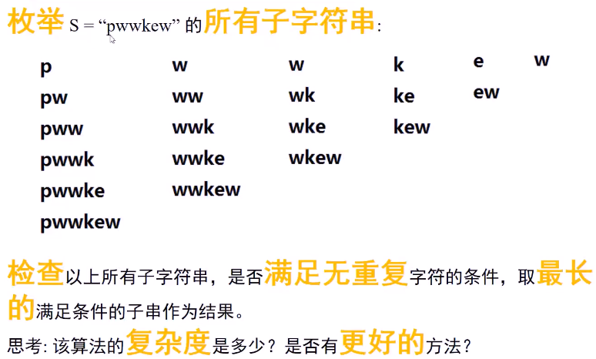

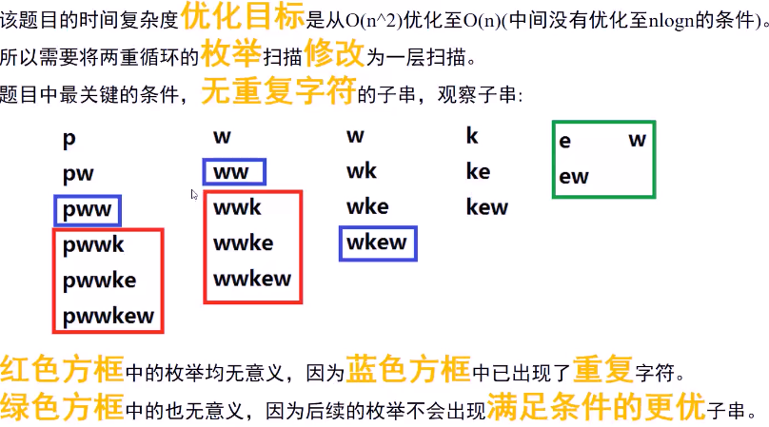

算法思路：

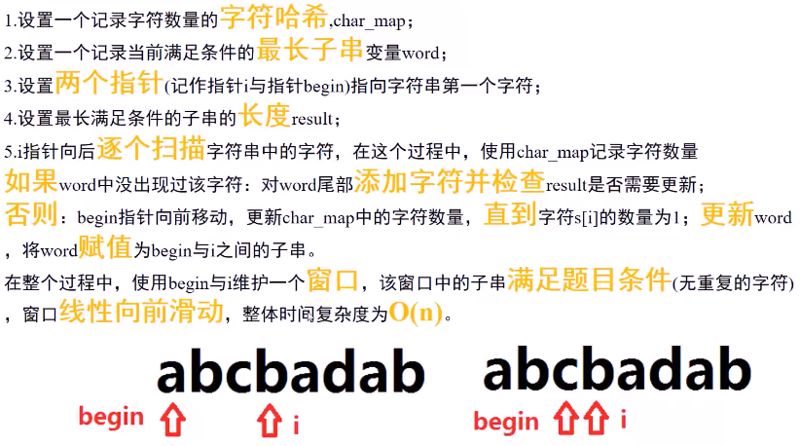

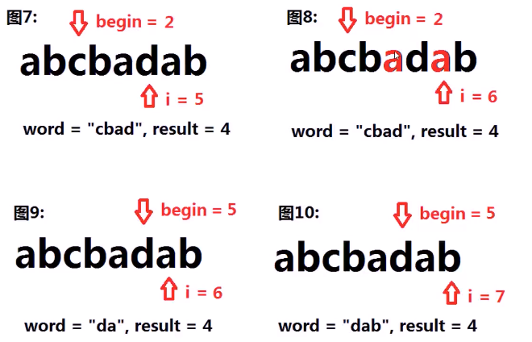

## Java代码

public int **lengthOfLongestSubstring**(String str) {

if(str == null || str.length() == 0) return 0;

if(str.length() == 1) return 1;

char[] chars = str.toCharArray();//字符串转成数组

int left = 0,right = 0,result = 0;//初始化参数

boolean[] hashTable = new boolean[128];

while(right < chars.length ){

if(!hashTable[chars[right]]){//字符第一次出现

hashTable[chars[right]] = true;

}else{//第二次出现

result = (result >= (right - left)) ? result : (right - left);//更新result

while(chars[left] != chars[right]){

hashTable[chars[left]] = false;//将移除窗口的置为false

left++;

}

left++;

}

right++;

}

//若最后一字符不是重复的，则需要再次更新result，如"abc"、"abcaefg"

**result = (result >= (right - left)) ? result : (right - left);**

return result;

}

C语言代码：

